AP Environmental Summer Assignment 2018
Welcome to APES! I am very happy that you have decided to take this course and embark on what I hope will be an exciting, beneficial and relevant educational journey. Your summer assignment is to perform several tasks to help you prepare for a successful year and get you thinking about our environment and how humans affect it. You are expected to enter the course with a good understanding of basic science and math concepts, so one goal of this assignment is to help you brush up on these, as we will be building upon and referencing these throughout the year. You are also required to get outside and contemplate our beautiful world. An answer key for the math portion will be posted in class. If you have questions, please feel free to email me at rogersla@fultonschools.org. I will be checking my email (somewhat) regularly. Please don’t leave this all until the few days before school begins - don’t be the “pro” in procrastinator! Have a fun summer and I look forward to an exciting year of APES!
Cheers! Mrs. Rogers

This summer assignment consists of the following parts which are presented on these 7 pages:
- Introductory email: Email me, Mrs. Laurie Rogers, at rogersla@fultonschools.org by Thursday 8/02/18 and tell me your name, something you love about nature, why you are taking APES, and a specific goal you have for the class.
- Prerequisite Basic Scientific Concepts review: Work is due first day of class. You are responsible for knowing these terms/concepts. We will have a concepts assessment on Friday of the first week.
- Math Review Problems: Work is due first day of class. Basic math skills (without the use of a calculator – oh no!) are a requirement for APES. Sharpen up your math skills and complete the math questions without using a calculator, as you will not be allowed to use a calculator for the exam, and thus during the class! Show all work. An AP Environmental Science Math Review is also posted for your reference if you have forgotten how to do some calculations. Be prepared for a math assessment on Friday of the first week. Answers will be posted in Room 132.
- Geography Review: Work is due first day of class. The physical and political boundaries of our world are reviewed. Be prepared for a map assessment on Friday of the first week.
- “Get outside yourself”ie! (Thank you REI). Explore a park with this photo assignment! Due 2nd day of class.
Part 2. Prerequisite Basic Scientific Concepts:
You should be familiar with the following terms/concepts from chemistry, biology and earth science. Create a set of flash cards or a definitions list.
Matter | Radioactive decay | Photosynthesis
Elements | Fission vs Fusion | Cellular respiration
Compounds | Half-life | Aerobic vs anaerobic respiration
Atoms | Law of Conservation of Matter | Adaptation
Protons, neutrons, electrons | 1st Law of Thermodynamics | Mutation
Atomic number vs Mass number | 2nd Law of Thermodynamics | Biodiversity
Isotopes | Eukaryotic vs prokaryotic | Extinction
Ion | Gene | Atmosphere/lithosphere/hydrosphere
pH | Trait | Plate tectonics
Buffer | Chromosome | Weathering
Ionic bonding | Species | Climate vs weather
Covalent bonding | Population | watershed
Hydrogen bonding | Community | Climate change
polarity | Ecosystem | Rocks vs minerals
Organic vs Inorganic compounds | Producers/autotrophs | Biomes
Hydrocarbons | Consumers/heterotrophs | deforestation
Physical vs chemical change | Decomposers | Pollution
Concentration | Detritivore | sustainability
Natural vs Synthetic | Keystone species | Niche
Kinetic vs Potential energy | Invasive species | habitat
Energy efficiency | Biogeochemical cycles | Energy pyramid
You should also know the names of the following chemical compounds and elements:
CO₂, CO, C₆H₁₂O₆, CH₄, H₂, H₂O, N₂, NO_{x}, NH₃, NO₃⁻, O₂, O₃, P, PO₄³⁻, S, SO₂, Cl, K, NaCl, Pb, Hg, Rn, U, CFC
Part 3. Math Review (no calculators!):
Work the following 50 practice problems on a separate sheet, and remember to show all your work, including units, and try not to use your calculator! Resist temptation, you can do it! If you need to refresh your memory on how to do these problems, please refer to the handout “AP Environmental Science Math Review” posted on this website. Topics: Decimals, Averages, Percentages, metric conversions, Scientific Notation, Temperature conversions, Dimensional Analysis

Back to Basics:
- 1.678 + 2.456 =
- 344.598 + 276.9 =
- 45.937 – 13.43 =
- 90.3 – 32.679 =
- 324.45 x 98.4 =
- 1256.93 x 12.38 =
- 64.5 / 5 =
- 114.54 / 34.5 =
- Find the average of the following numbers: 11, 12, 13, 14, 15, 23, and 29
- Find the average of the following numbers: 124, 456, 788, and 343
- Find the average of the following numbers: 4.56, .0078, 23.45, and .9872
Percentages
- Thirteen percent of a 12,000 acre forest is being logged. How many acres will be logged?
- A water heater tank holds 280 gallons. Two percent of the water is lost as steam. How many gallons remain to be used?
- 14,000 acres of a 40,000 acre forest burned in a forest fire. What percentage of the forest was damaged?
- You have driven the first 150 miles of a 2000 mile trip. What percentage of the trip have you traveled?
- Home prices have dropped 5% in the past three years. An average home in Indianapolis three years ago was $130,000. What’s the average home price now?
- The Greenland Ice Sheet contains 2,850,000 cubic kilometers of ice. It is melting at a rate of .006% per year. How many cubic kilometers are lost each year?
- 235 acres, or 15%, of a forest is being logged. How large is the forest?
- Calculate the percentage growth for a county with a population of 6 million in a year in which it had 100,000 births, 70,000 deaths, 30,000 immigrants and 40,000 emigrants.
- A coal fired power plant is 35% efficient. If one ton of coal contains 20 million Btu of energy, then how many Btu of waste heat are produced per ton of coal?
- If the concentration of iron in a water supply changes from 45ppm to 8 ppm in a ten-year period, what is the annual percent change of the iron concentration?
- If 25% of a natural area is to be developed, leaving 750 acres untouched, how many acres are to be developed?
Metric Conversions
Common Metric prefixes:
µ (Micro) = 1/1,000,000 = 10 ⁻⁶ m (milli) = 1/1000 = 10 ⁻³ c (centi) = 1/100= 10 ⁻² k (kilo) = 1000 = 10³
M (mega) = 1,000,000 = 10⁶ G (giga) = 1,000,000,000 = 10⁹ T(tera) = 1,000,000,000,000 = 10¹²
ppm = parts per million ppb = parts per billion
- 1200 kilograms = ? milligrams
- 2.3 Gbyte = ? Mbyte
- 6544 liters = ? milliliters
- .078 kilometers = ? meters
- 17 milligrams = ? kilograms
Temperature Conversions: Formulas: °C = 5/9 (°F – 32) and °F = (°C x 9/5) + 32
- a) 85°F = __ °C b) 15 °C =___ °F c) -35 °C = ___ °F
Scientific Notation
Write the following numbers in scientific notation:
- 145,000,000,000
- .000348
- 135 trillion
- 1 millionth
Complete the following calculations:
- (3 x 10³) + (4 x 10³)
- (7.89 x 10⁻⁶ )+ (2.35 x 10⁻⁸)
- (9.85 x 10⁴) – (6.35 x 10⁴)
- (2.9 x 10¹¹) – (3.7 x 10¹³)
- (1.32 x 10⁸) X (2.34 x 10⁴)
- 3.78 x 10³ ) X (2.9 x 10²)
- three million times eighteen thousand
- one thousandth of seven thousand
- (3.45 x 10⁹) / (2.6 x 10³)
- (1.98 x 10⁻⁴) / (1.72 x 10⁻⁶)

Dimensional Analysis (remember this??)
Handy Conversion factors:
1 square mile = 640 acres 1 hectare (Ha) = 2.47 acres 1 kw-hr = 3,413 BTUs
1 barrel of oil = 159 liters 1 metric ton = 1000 kg 1 inch = 2.54 cm 1 mile= 1.6 km or 5280 feet
1 pound = 16 oz or 454 grams 1 kg = ton = 2000 lbs 1 liter = 1.057 quart 1 mL = 1 cm³
- 134 miles = ? inches
- 8.9 x 10⁵ ounces = ? tons
- 1.35 kilometers per second = ? miles per hour
- A city that uses ten billion BTUs of energy each month is using how many kilowatt-hours of energy?
- A 340 million square mile forest is how many hectares?
- The total amount of freshwater on earth is estimated to be 3.7 x 10⁸ km³. What is the volume in L?
- Your car gets 15 miles per gallon, and your friend’s car gets 25 mpg. If you go on a 200 mile road trip in your friend’s car, and gas costs $2.50 per gallon, how much money will you save in gas by using your friend’s car instead of your car?
- If one barrel of crude oil provides six million BTUs of energy, how many BTUs will one liter of crude oil provide?
- Fifty eight thousand kilograms of solid waste is equivalent to how many metric tons?
- Sapelo Island, off the coast of Georgia, is 16500 acres in size. If one inch of rain falls on the island, how many cubic feet of rain fell on the island?
- Your house is 1000.0 sq ft, and you have a natural gas furnace. 60,000. BTUs of heat per square foot are required to heat your house for one winter season. A) How many BTUs of energy will be needed? B) If one cubic foot of natural gas supplies 1,000. BTUs of heat, how many cubic feet of natural gas will be needed for this one winter season?
- Suppose my car gets 32 miles to the gallon of gas and I drive approximately 15,000 miles per year. How many gallons of gas do I use in a year? If one gallon of gasoline emits 20 pounds of CO₂, when burned in the internal combustion engine of my car, how much CO₂ does my car emit each year?

Part 4: World Geography Refresher:
Please print out 2 copies of the attached map and label the following on the maps. Please print neatly & legibly, you may need to create a key.
- World Political Map: label the following:
  - all continents
  - all oceans
  - Equator, prime meridian, Topic of Cancer, Tropic of Capricorn, Arctic Circle, Antarctic Circle, latitude, longitude
  - Countries: China, Japan, Korea, India, Pakistan, Indonesia, Philippines, Brazil, Chile, Cuba, Mexico, Haiti, Dominican Republic, Hawaiian Islands, Galapagos Islands, Nigeria, Saudi Arabia, Iran, Iceland, England, Germany, Russia
- World Physical Map: Label the following:
  - Rivers: Amazon, Congo, Nile, Niger, Danube, Volga, Ganges, Yangtze, Mississippi
  - Lakes/Seas/ Regions: Great Lakes, Lake Chad, Lake Victoria, Gulf of Mexico, Red Sea, Aral Sea, Black Sea, Mediterranean Sea, Bering Sea, Hudson Bay
  - Mountain ranges: Andes, Alps, Himalayas, Rockies, Sierra Nevada region, Cascades, Appalachians
  - Other: San Andreas fault, Everglades, Grand Banks

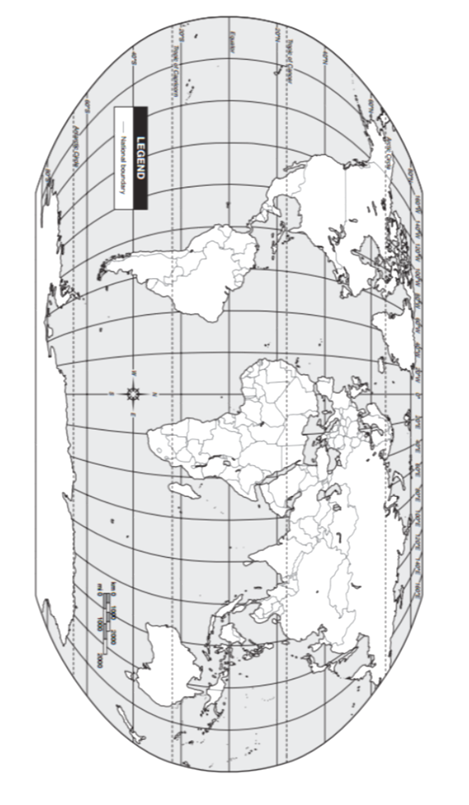
Part 5. Get outside yourself-ie! (This is due the 2nd day back)
Get out and enjoy the glorious summer weather and explore our beautiful natural world! Please visit at least one park (local, state, or national), take a picture of yourself at the park, and write 4 paragraphs reflecting on your visit, describing and providing information about the park, its location, history, the flora and fauna (identify what you observed), visible signs of human impact in the park, and your overall impressions. You may need to do some research: please give me more than just “I saw pine trees and squirrels”. 😊

Print and cut out the picture of Mr. Apes below (if you wish to include him with you in your photo for extra credit!)

