Advanced Placement United States History
APUSH Summer Assignment 2017-2018
Raymond Brown: Brownrj@fultonschools.org
Tom Henderson: HendersonTM@fultonschools.org

Allow me to welcome to AP US History. This is a course that will cover the entirety of United States history from the first European settlers to present day. Because of the way that the AP test is organized and weighted it is important that we get started right away. Your summer assignment will cover all of time period 1 (1497-1601).
Summer assignment part 1: there are 6 word docs and 5 helpful powerpoints attached to help you with your work. Below are the assignments that you need to have ready on the first day of school.
- Exploration Chart
- Bartolome de las Casas Analysis
- Plagues and Peoples Columbian exchange Questions
- Howard Zinn’s Columbus Analysis
- Early Natives Chart
- Preparation for Columbus Essay

Summer Assignment Part 2: For this part you will need to purchase the book America a narrative History Brief 9th edition. You can buy this book in two ways, one looks like this:
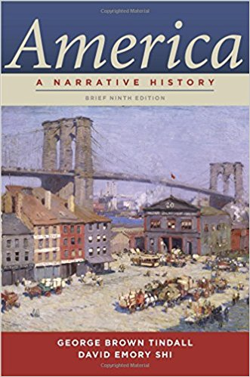
This is good for the whole year.
The second way is purchasing both the first and second volumes. They look like this:
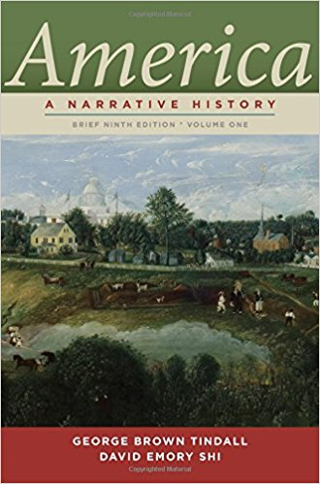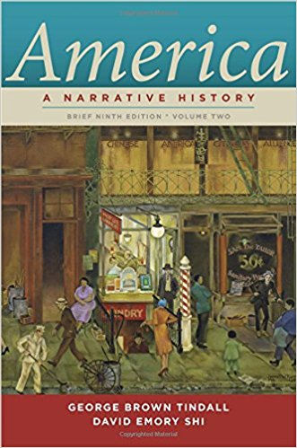
This is Volume 1 This is Volume 2
This book will be required for the entire school year. The most affordable way to purchase it is through a site like Amazon, Chegg.com, or half.com and BUY THEM USED.

You will need to have the first chapter read by the first day of class. Please takes notes on this chapter as we will start our first of many open note reading quizzes. Learning to take notes on what you read is imperative to succeeding in this class.

If you have any questions please email either of the instructors at their listed emails above.

