Period 1 Key Concept Packet

*Key Concept 1.1 - Big Geography and the Peopling of the Earth*

**Use your Amsco review book to complete this. You also might find the site** [**AP Worldipedia**](http://apworldipedia.com/index.php?title=Key_Concept_1.1_Big_Geography_and_the_Peopling_of_the_Earth) **helpful. Packet was originally made by Mr. Scott Wike and Ms. Naylor, and modified by Mr. Anderson.**

**YOU SHOULD PRINT AND FILL OUT BY HAND**

1. *Archeological evidence indicates that during the Paleolithic era, hunting-foraging bands of humans gradually migrated from their origin in East Africa to Eurasia, Australia, and the Americas, adapting their technology and cultures to new climate regions.*
2. What diverse and sophisticated tools were developed by humans to adapt to their new environments? Use fire as one example.

|  |  |
| --- | --- |
| **Tool Name** | **Purpose** |
| Fire |  |
|  |  |

1. *People lived in small groups that structured social, economic, and political activity. These bands exchanged people, ideas, and goods.*

How did hunter-forager societies organize themselves socially and politically?

How did different groups interact with each other?

What were the general patterns of art and religion for hunter-forager societies?

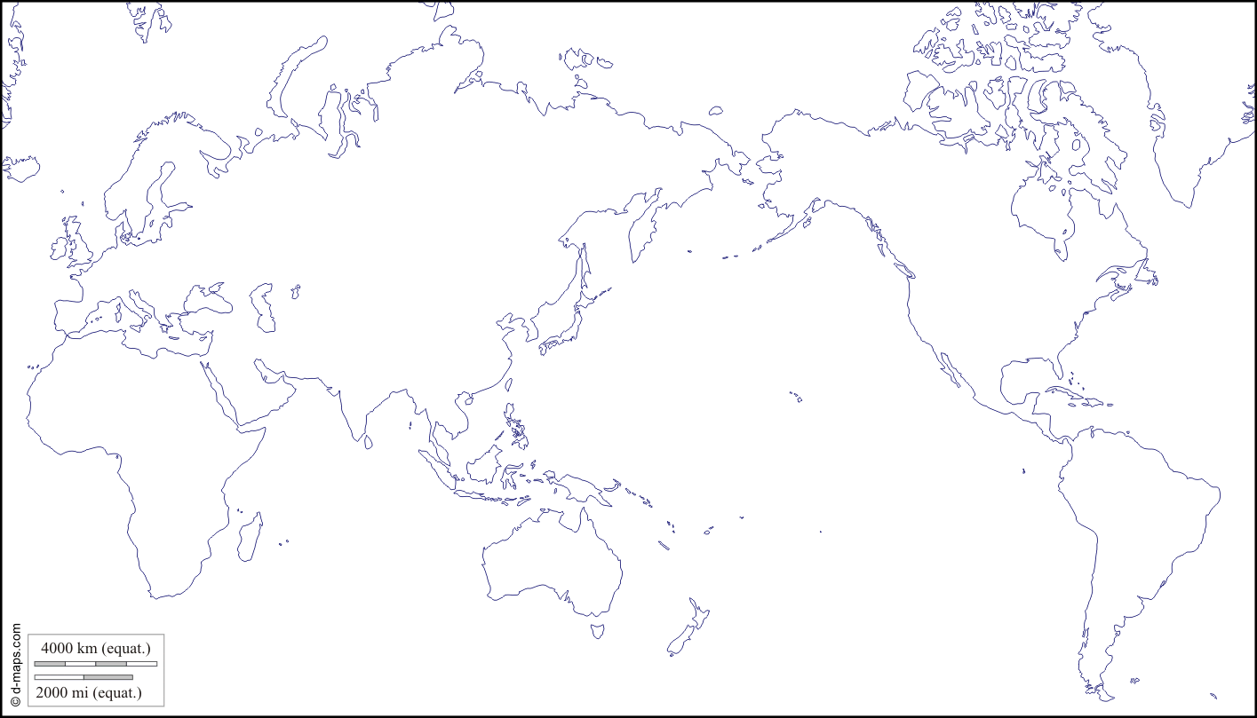

Map out early human migration on the map above using lines and arrows. Make sure to **star** the point where human migrations originated.

*Key Concept 1.2 - The Neolithic Revolution and Early Agricultural Societies*

1. *Beginning about 10,000 years ago, the Neolithic Revolution led to the development of more complex economic and social systems.*

**Label** the following permanent agricultural settlements on the map below: Mesopotamia, Nile River Valley (RV), Indus RV, Yellow RV, Mesoamerica, Andean civilization, Sub-Saharan Africa, Papua New Guinea

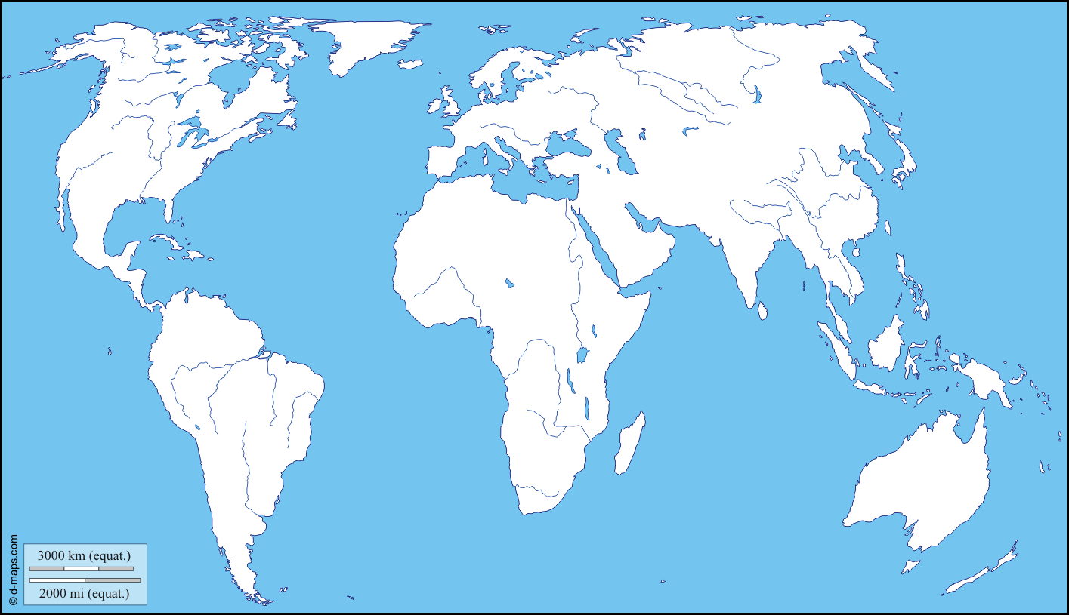

From the settlements listed above, identify a locally available plant and animal that were domesticated.

|  |  |
| --- | --- |
| Mesopotamia |  |
| Nile River Valley |  |
| Sub-Saharan Africa |  |
| Indus River Valley |  |
| Yellow River Valley |  |
| Papua New Guinea |  |
| Mesoamerica |  |
| Andes |  |

1. Pastoralism developed in Afro-Eurasian grasslands. What is pastoralism? What was their way of life? What impact they did they make on the environment and on settled peoples?
2. *Agriculture and pastoralism began to transform human societies.*
3. Explain how pastoralism and agriculture led to the following:

|  |  |
| --- | --- |
| Abundant Food Supplies |  |
| Labor Specialization- examples: Artisans and Warriors |  |
| Development of Elites (political and religious) |  |
| Growth of Villages, Town, and Cities |  |
| Governments |  |
| Religion |  |

1. Identify and explain THREE technological innovations that led to improvements in agricultural production, trade, and transportation

|  |  |
| --- | --- |
| **Innovation** | **Impact on agricultural production, trade, and/or transportation** |
|  |  |
|  |  |
|  |  |

1. Explain **how** patriarchal social organization developed in both pastoralist and agrarian societies.

|  |  |
| --- | --- |
| Agrarian |  |
| Pastoralist |  |

*Key Concept 1.3 The Development and Interactions of Early Agricultural, Pastoral, and Urban Societies*

1. Core and foundational civilizations developed in a variety of geographical and environmental settings where agriculture flourished, including **Mesopotamia** in the Tigris and Euphrates River Valleys, **Egypt** in the Nile River Valley, **Mohenjo-Daro and Harappa** in the Indus River Valley, **Shang** in the Yellow River (or Huang He) Valley, **Olmec** in Mesoamerica, and **Chavin** in Andean South America.
2. For the civilizations listed below, explain how their rulers claimed *divine connections* (religious) to justify their power

|  |  |
| --- | --- |
| China (Xia and Shang) |  |
| Egyptian Civilization |  |
| Mesopotamia (Sumer) |  |

Select TWO civilizations from 1.3.I (the ones bolded above) and explain how rulers organized and deployed their military to create powerful new states.

|  |  |
| --- | --- |
| **Civilization Name** | **Military Organization & Deployment** |
|  |  |
|  |  |

1. Select ONE civilization from the list above and explain how geographic location made it favorably situated in relation to the categories listed (*suggestion: Hittites*)

|  |  |
| --- | --- |
| **Civilization Name** |  |
| Access to Natural Resources |  |
| Food Surpluses |  |
| Population Growth |  |
| Territorial Expansion |  |

1. Identify and explain TWO examples of how pastoralists transformed warfare against agrarian civilizations through the development and dissemination of new weapons and modes of transportation

|  |  |
| --- | --- |
| Weapon |  |
| Mode of Transportation |  |

1. *Culture played a significant role in unifying states through law, language, literature, religion, myths, and monumental art.*
2. Complete the grids that follow on the next few pages – this is a survey of examples of monumental architecture and urban planning amongst early civilizations.

|  |  |
| --- | --- |
| Identify/Label | http://www.mesopotamia.co.uk/ziggurats/explore/images/zig.gif |
| What civilization created it? |  |
| Approximately when was it created? |  |
| What purpose does it serve? |  |

|  |  |
| --- | --- |
| Identify/Label | http://sweetclipart.com/multisite/sweetclipart/files/pyramids_line_art.png |
| What civilization created it? |  |
| Approximately when was it created? |  |
| What purpose does it serve? |  |

|  |  |
| --- | --- |
| Identify/Label |  |
| What civilization created it? |  |
| Approximately when was it created? |  |
| What purpose does it serve? |  |

|  |  |
| --- | --- |
| Identify/Label | http://mrholmes.pbworks.com/f/1268406095/Chrismap.jpg |
| What civilization created it? |  |
| Approximately when was it created? |  |
| What purpose does it serve? |  |

|  |  |
| --- | --- |
| Identify/Label | http://callisto.ggsrv.com/imgsrv/FastFetch/UBER2/eca_02_img0131 |
| What civilization created it and approximately when was it created? |  |
| What Purpose does it serve? |  |

1. Complete the grid below as examples of systems of record keeping that arose amongst early civilizations.

|  |  |
| --- | --- |
| Type of Writing System | https://ancientegyptsteckbeck.wikispaces.com/file/view/hiero.gif/108130405/655x382/hiero.gif |
| What civilization created it? |  |
| Identify a unique characteristic of this writing system |  |

|  |  |
| --- | --- |
| Type of Writing System | http://www.mirrorservice.org/sites/gutenberg.org/3/6/7/5/36750/36750-h/images/illus704b.png |
| What civilization created it? |  |
| Identify a unique characteristic of this writing system |  |

|  |  |
| --- | --- |
| Type of Writing System |  |
| What civilization created it? |  |
| Identify a unique characteristic of this writing system |  |

1. States developed legal codes that reflected existing hierarchies and facilitated the rule of governments over people. Explain how the Code of Hammurabi exemplifies this theme.
2. Complete the grid below to identify the new religious beliefs of this period (each of which would continue to have strong influence in later periods).

|  |  |  |  |
| --- | --- | --- | --- |
|  | **Vedic Religions** | **Hebrew monotheism (Judaism)** | **Zoroastrianism** |
| **Theism (mono, poly, etc)** |  |  |  |
| **Relative Location** |  |  |  |
| **Approx. Founding** |  |  |  |
| **Religious Text(s)** |  |  |  |
| **Key God(s)** |  |  |  |
| **Key Figures/Prophets** |  |  |  |
| **Main Beliefs** |  |  |  |

1. Select ONE of the trade routes listed and complete the grid below to explain how trade expanded throughout this period from local to regional to interregional, with civilizations exchanging goods, cultural ideas, and technology.

Trade between Mesopotamia & Egypt; OR between Egypt & Nubia; OR between Mesopotamia & the Indus Valley

|  |  |
| --- | --- |
| **Trade Route:** |  |
| **Goods, Ideas, and/or Technology Sent** | **Goods, Ideas, and/or Technology Received** |
|  |  |

**\*\*\*Include below:**

* 5 more important facts about the Sumerians/Babylonians
* What did the Phoenicians do?
* 5 more important facts about Ancient Egypt?
* 5 more important facts about Ancient China

**KEY VOCABULARY – Define ALL words on a separate sheet of paper and attach to the back of this packet. After this, pat yourself on the back, because you are done . . . awesome job!!**

* Foraging
* Kinship group/clan
* Domestication
* Agrarian
* Irrigation
* Pastoralism
* Nomads
* Steppe
* Jericho & Catal Huyuk
* City-state
* Social stratification
* Hierarchies
* Elites
* Specialization of labor
* Patriarchy
* Metallurgy
* Textiles
* Divine
* Mesopotamia
* Ziggurat
* Cuneiform
* Epic of Gilgamesh
* Marduk
* Code of Hammurabi
* Pyramid
* Pharaoh
* Ma’at
* Papyrus
* Hieroglyphics
* Akhenaten
* Phoenician alphabet
* Polytheism
* Monotheism
* Yahweh
* Hebrew Bible
* Diaspora
* Oracle bones
* Divination
* Ancestor veneration
* Mandate of Heaven
* Culture
* Artisan
* Merchant
* Scribe
* Barter
* Hittities
* Chariots
* Neo-Assyrians