Advanced Placement United States History
APUSH Summer Assignment 2019-2020
Raymond Brown: Brownrj@fultonschools.org

Allow me to welcome to AP US History. This is a course that will cover the entirety of United States history from the first European settlers to present day. Because of the way that the AP test is organized and weighted it is important that we get started right away. Your summer assignment will cover all of time period 1 (1497-1601).
Summer assignment part 1: there are 2 word docs and 5 helpful powerpoints attached (combined into 1 file) to help you with your work. Below are the assignments that you need to have ready on the first day of school.
- Exploration Charts
- Short answer questions

Summer Assignment Part 2: For this part you will need to purchase the book America a narrative History Brief 9th edition. You can buy this book in two ways, one looks like this:
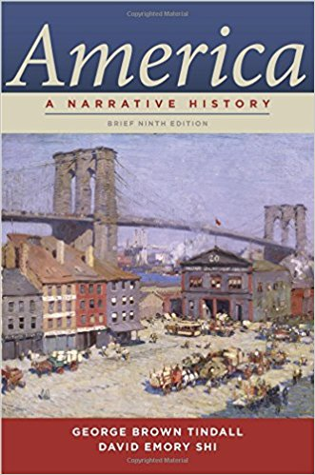
This is good for the whole year.
The second way is purchasing both the first and second volumes. They look like this:
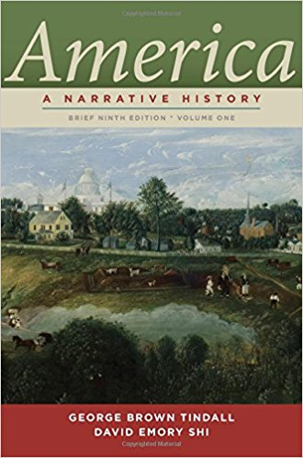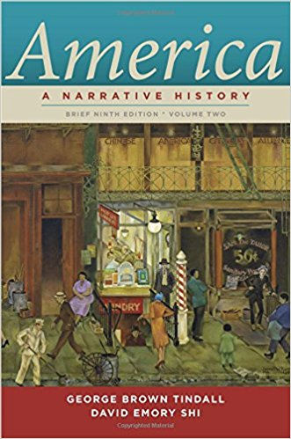
This is Volume 1 This is Volume 2
This book will be required for the entire school year. The most affordable way to purchase it is through a site like Amazon, Chegg.com, or half.com and BUY THEM USED.

You will need to have the first chapter read by the first day of class. Please takes notes on this chapter as we will start our first of many open note reading quizzes. Learning to take notes on what you read is imperative to succeeding in this class.
IF YOUR BOOKS DON’T LOOK LIKE THIS YOU HAVE THE WRONG VERSION. It is imperative that you have the correct versions, amazon and other retailers have shipped out the wrong versions in the past on accident, it does happen so please check.

If you have any questions please email the instructor at his listed emails above.

Part 3: This should be a fun summer activity for you to do. You are to complete at least 1 Jr. Park Ranger activity booklet at one of Americas National Parks and acquire a Jr. Park ranger badge or patch. This can be done at any national park throughout the country.
There are three of them close to Johns Creek: Kennesaw Mountain National Battlefield Park, Martin Luther king Jr National Historic Park, and the Chattahoochee River National Recreation Area (the Island Ford Unit is the main headquarters). If for some reason you are unable to go to one of these local treasures, there are 14 badges available online through nps.org. (If you chose the online option it must be done first thing in June as it takes the NPS a little over a month to mail the badges)

